
Department of Computer Science

Lab Manual
of
SPEECH PROCESSING AND RECOGNITION
MAI574
Class Name: V MScAIML

Master of Science Artificial Intelligence and Machine Learning
2025-26

Prepared by: Verified by:
Pratik Deshmukh Faculty name:

Department Overview
Department of Computer Science of CHRIST (Deemed to be University) strives to shape outstanding computer professionals with ethical and human values to reshape nation’s destiny. The training imparted aims to prepare young minds for the challenging opportunities in the IT industry with a global awareness rooted in the Indian soil, nourished and supported by experts in the field.

Vision
The Department of Computer Science endeavours to imbibe the vision of the University “Excellence and Service”. The department is committed to this philosophy which pervades every aspect and functioning of the department.

Mission
“To develop IT professionals with ethical and human values”. To accomplish our mission, the department encourages students to apply their acquired knowledge and skills towards professional achievements in their career. The department also moulds the students to be socially responsible and ethically sound.

Introduction to the Programme
Machines are gaining more intelligence to perform human like tasks. Artificial Intelligence has spanned across the world irrespective of domains. MSc (Artificial Intelligence and Machine Learning) will enable to capitalize this wide spectrum of opportunities to the candidates who aspire to master the skill sets with a research bent. The curriculum supports the students to obtain adequate knowledge in the theory of artificial intelligence with hands-on experience in relevant domains with tools and techniques to address the latest demands from the industry. Also, c andidates gain exposure to research models and industry standard application development in specialized domains through guest lectures, seminars, industry offered electives, projects, internships, etc.

Programme Objective
● To acquire in-depth understanding of the theoretical concepts in Artificial Intelligence and Machine Learning
● To gain practical experience in programming tools for Data Engineering, Knowledge Representation, Artificial intelligence, Machine learning, Natural Language Processing and Computer Vision.
● To strengthen the research and development of intelligent applications skills through specialization based real time projects.
● To imbibe quality research and develop solutions to the social issues.

Programme Outcomes:
PO1 : Conduct investigation and develop innovative solutions for real world problems in industry and research establishments related to Artificial Intelligence and Machine Learning PO2 : Apply programming principles and practices for developing automation solutions to meet future business and society needs.
PO3 : Ability to use or develop the right tools to develop high end intelligent systems
PO4 : Adopt professional and ethical practices in Artificial Intelligence application development
PO5 : Understand the importance and the judicious use of technology for the sustainability of the environment.

MAI574– SPEECH PROCESSING AND RECOGNITION

Total Teaching Hours for Semester: 75 (3+4)
Max Marks:150 Credits: 5

Course Objectives
This course enables the learners to understand fundamentals of speech recognition, speech production and representation. It also enables the learners to impart knowledge on automatic speech recognition and pattern comparison techniques. This course helps the learners to develop automatic speech recognition model for different applications.

Course Outcomes
After successful completion of this course students will be able to
CO1: Understand the speech signals and represent the signal in time and frequency domain.
CO2: Analyze different signal processing and speech recognition methods.
CO3: Implement pattern comparison techniques and Hidden Markov Models (HMM)
CO4: Develop speech recognition system for real time problems.

Unit-1 Teaching Hours: 15
FUNDAMENTALS OF SPEECH RECOGNITION
Introduction- The Paradigm for Speech Recognition- Brief History of speech recognition research- The Speech Signal: The process of speech production and perception in human beings- the speech production system- representing speech in time and frequency domain- speech sounds and features.
Lab Programs:
- Implement the task that takes in the audio as input and converts it to text.
- Apply Fourier transform and calculate a frequency spectrum for a signal in the time domain.

Unit-2 Teaching Hours: 15
2.1 APPROACHES TO AUTOMATIC SPEECH RECOGNITION BY MACHINE:
The acoustic phonetic approach-The pattern recognition approach-The artificial intelligence approach.
2.2 SIGNAL PROCESSING AND ANALYSIS METHODS FOR SPEECH RECOGNITION:
Introduction- spectral analysis models- the bank of filters front end processor- linear predictive coding model for speech recognition- vector quantization.
Lab Programs:
3. Implement sampling and quantization techniques for the given speech signals.
4. Explore linear predictive coding model for speech recognition

Unit-3 Teaching Hours: 15
PATTERN COMPARISON TECHNIQUES
Speech detection- distortion measure- Mathematical consideration- Distortion measure – Perceptual consideration- Spectral Distortion Measure- Incorporation of spectral dynamic feature into distortion measure- Time alignment and normalization.
Lab Programs:
- Demonstrate different pattern in the given speech signal
- Implement time alignment and normalization techniques

Unit-4 Teaching hours: 15
THEORY AND IMPLEMENTATION OF HIDDEN MARKOV MODELS:
Introduction- Discrete time Markov processes- Extension to hidden Markov Models- Coin - toss models- The urn and ball model- Elements of a Hidden Markov Model- HMM generator of observation- The three basic problems for HMM’s- The Viterbi algorithm- Implementation issues for HMM’s.
Lab Programs:
7. Implement simple hidden Markov Model for a particular application.
8.Apply Viterbi dynamic programming algorithm to find the most likely sequence of hidden states.

Unit-5 Teaching Hours: 15
TASK ORIENTED APPLICATION OF AUTOMATIC SPEECH RECOGNITION:
Task specific voice control and dialog- Characteristics of speech recognition applications- Methods of handling recognition error- Broad classes of speech recognition applications- Command and control applications- Voice repertory dialer- Automated call-type recognition- Call distribution by voice commands- Directory listing retrieval- Credit card sales validation.
Lab Programs:
9. Demonstrate automatic speech recognition for Call distribution by voice commands.
10. Apply speech recognition system to access telephone directory information from spoken spelled names (Directory listing retrieval).

Text Books and Reference Books
[1] Fundamentals of Speech Recognition, Lawrence R Rabiner and Biing- Hwang Juang. Prentice-Hall Publications, 20209.
[2] Introduction to Digital Speech Processing, Lawrence R. Rabiner, Ronald W. Schafer, Now Publishers, 2015.

Essential Reading / Recommended Reading
- Intelligent Speech Signal Processing, Nilanjan Dey, Academic Press, 2019.
- Speech Recognition-The Ultimate Step-By-Step Guide, Gerardus Blokdyk, 5STARCooks,2021.
- Automatic Speech Recognition- A Deep Learning Approach, Dong Yu, Li Deng, Springer-Verlag London, 2015.

Web Resources:
- www.w3cschools.com
- https://www.simplilearn.com/tutorials/python-tutorial/speech-recognition-in-python
- https://realpython.com/python-speech-recognition/
- https://cloud.google.com/speech-to-text/docs/tutorials
- https://www.coursera.org/courses?query=speech%20recognition
- https://pylessons.com/speech-recognition

CO – PO Mapping
 | PO1 | PO2 | PO3 | PO4 | PO5
CO1 | 3 | 1 |  |  | 1
CO2 | 2 | 2 |  |  | 1
CO3 | 1 | 3 | 1 |  | 2
CO4 | 1 | 1 | 3 | 1 | 3

LIST OF PROGRAMS

M.Sc AIML 2025-2026

Sl.no | Title of lab Experiment | Page number | RBT | CO
1 | Sampling and Reconstruction of Speech Signals |  | L3 | CO1,3
2 |  |  | L3 | CO2,3
3 |  |  | L3 | CO3
4 |  |  | L3 | CO3
5 |  |  | L3 | CO3
6 |  |  | L3 | CO3,4
7 |  |  | L4 | CO3
8 |  |  | L3 | CO3
9 |  |  | L3 | CO4
10 |  |  | L5 | CO4

Evaluation Rubrics:
(1) Implementation: 5 marks.
(2) Complexity and Validation: 3 marks.
(3) Documentation & Writing the inference: 2 marks.
Submission Guidelines:
- Make a copy of the lab manual template with your <name_reg:no_subject name >,

- Copy the given question and the answer (lab code) with results, followed by the conclusion of that lab. Title the lab as lab number.
- Keep updating your lab manual and show the lab manual of that particular lab for evaluation.
- Create a Git Repository in your profile <SPR lab-reg no> . Follow a different branch for each lab <Lab 1, Lab 2…>, and push the code to Git. The link should be provided in Google Classroom along with the PDF of the lab manual.
- Upload the PDF to Google Classroom before the deadline.

Lab 1
Lab Exercise I: Sampling and Reconstruction of Speech Signals

Aim
To study sampling and reconstruction of speech signals at different sampling rates, evaluate reconstruction using zero-order hold and linear interpolation, and implement the source-filter model to analyze the effect of filtering, sampling, and reconstruction on speech quality.

(1) Implement sampling and quantization techniques for the given speech signals.
(a) Plot the time domain representation of the original speech signal.
(b) Sample the speech signal at different sampling rates (e.g., 8kHz, 16kHz, and 44.1kHz).
(c) Plot sampled speech signal for each of these sampling rates.
(d) Using the sampled signals from above, reconstruct the signal using:
(i) Zero-order hold (nearest-neighbor interpolation)
(ii) Linear interpolation.
(e) Calculate the Mean Squared Error (MSE) between the original and the reconstructed signals for both methods.
Write an inference on how sampling rates affect the quality and accuracy of the reconstructed speech signal.

Code with Results

import numpy as np
import matplotlib.pyplot as plt
from scipy.io import wavfile
from scipy import signal
import sounddevice as sd

Generate a Test speech.wav File (Optional)
If you don't have a .wav file, you can run the cell below to generate a simple test signal. It will create a 2-second sine wave at 440 Hz (the note "A") and save it as speech.wav. This ensures you have a valid file to work with for the rest of the lab.
# --- Generate a test WAV file ---
sample_rate_gen = 44100 # Hz
duration_gen = 10 # seconds
frequency_gen = 440 # Hz (A4 note)
# Generate a time vector
t_gen = np.linspace(0., duration_gen, int(sample_rate_gen * duration_gen), endpoint=False)
# Generate a sine wave
amplitude_gen = np.iinfo(np.int16).max * 0.5 # Use 50% of max amplitude
data_gen = amplitude_gen * np.sin(2. * np.pi * frequency_gen * t_gen)
# Write to a WAV file
wavfile.write("speech.wav", sample_rate_gen, data_gen.astype(np.int16))
print("Generated 'speech.wav' successfully.")
Generated 'speech.wav' successfully.

1. Load and Plot the Original Speech Signal
First, we need to load a speech signal from a .wav file. Make sure you have a speech file in your project directory or provide the correct path to it.
The code below will:
- Read the sampling rate and data from the .wav file.
- Normalize the audio data to be between -1 and 1.
- Create a time vector.
- Plot the speech signal's waveform.
# (1a) Plot the time domain representation of the original speech signal.
# --- Parameters ---
# PLEASE REPLACE WITH THE PATH TO YOUR SPEECH FILE
input_filename = 'speech.wav'
# --- Code ---
try:
# Read the audio file
original_rate, original_signal = wavfile.read(input_filename)
# Normalize the signal to be in the range [-1, 1]
if original_signal.dtype == 'int16':
original_signal = original_signal / 32768.0
elif original_signal.dtype == 'int32':
original_signal = original_signal / 2147483648.0
# Create a time axis
duration = len(original_signal) / original_rate
time = np.linspace(0., duration, len(original_signal))
# Plot the original speech signal
plt.figure(figsize=(12, 4))
plt.plot(time, original_signal)
plt.title('Original Speech Signal')
plt.xlabel('Time (s)')
plt.ylabel('Amplitude')
plt.grid(True)
plt.show()
except FileNotFoundError:
print(f"Error: The file '{input_filename}' was not found.")
print("Please make sure the file is in the correct directory and the filename is correct.")
# You can also play the audio to hear it
print("Playing original audio...")
sd.play(original_signal, original_rate)
sd.wait()
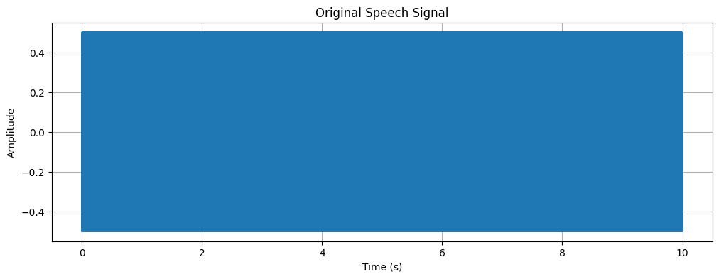
Playing original audio...

2. Sample the Speech Signal at Different Rates
Now, we will take the original continuous-time signal and convert it into a discrete-time signal by sampling it at different frequencies as required by the task (8kHz, 16kHz, and 44.1kHz). This process is also known as downsampling or decimation if the new sampling rate is lower than the original.
The code below will:
- Define a list of target sampling rates.
- Loop through each rate.
- Resample the original signal to the target rate using scipy.signal.resample.
- Plot each of the sampled signals. A stem plot is used to visualize the discrete nature of the samples.
# (1b, 1c) Sample the speech signal and plot the sampled signals
# --- Parameters ---
target_rates = [8000, 16000, 44100] # Hz
sampled_signals = {}
# --- Code ---
for rate in target_rates:
# Calculate the number of samples in the resampled signal
num_samples = int(len(original_signal) * rate / original_rate)
# Resample the signal
sampled_signal = signal.resample(original_signal, num_samples)
sampled_signals[rate] = sampled_signal
# Create a time axis for the sampled signal
sampled_time = np.linspace(0., duration, num_samples)
# Plot the sampled signal
plt.figure(figsize=(12, 4))
plt.stem(sampled_time, sampled_signal, basefmt=" ")
plt.title(f'Speech Signal Sampled at {rate / 1000} kHz')
plt.xlabel('Time (s)')
plt.ylabel('Amplitude')
plt.grid(True)
# To make the plot cleaner, you might want to plot only a small segment
plt.xlim(0.1, 0.12) # Zoom in to a 20ms segment to see the samples clearly
plt.show()
# You can also play the sampled audio to hear the difference
# print(f"Playing audio sampled at {rate / 1000} kHz...")
# sd.play(sampled_signal, rate)
# sd.wait()
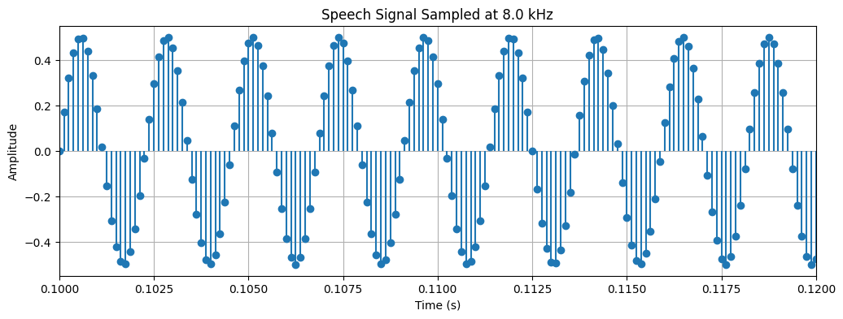
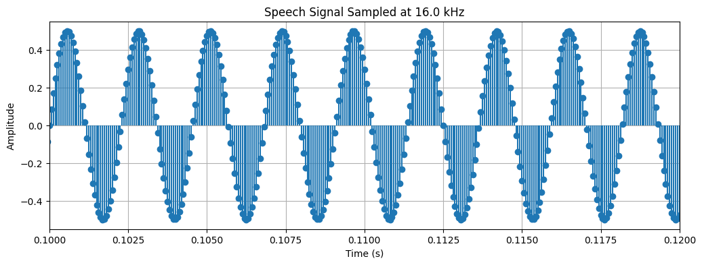
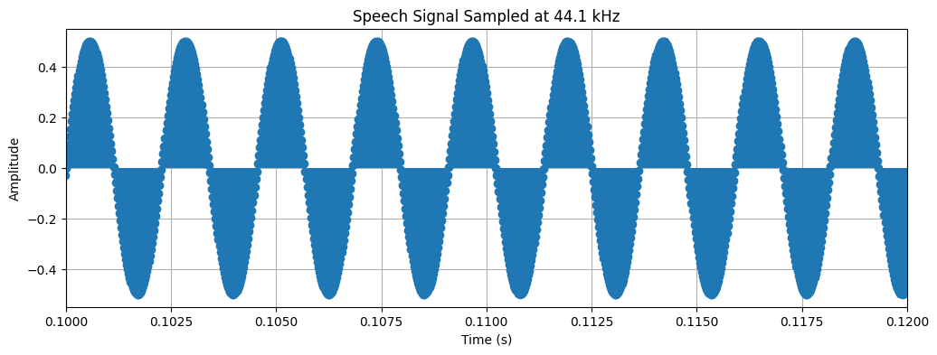

3. Reconstruct the Signal from Samples
After sampling, we have a discrete set of points. To get back to a continuous-like signal, we need to "fill in the gaps" between these points. This process is called reconstruction or interpolation. We will implement two basic methods:
- Zero-Order Hold (ZOH): This is the simplest method. It holds the value of each sample constant until the next sample is reached. This creates a "staircase" or blocky-looking signal. It's also known as nearest-neighbor interpolation.
- Linear Interpolation: This method connects consecutive samples with a straight line. It generally produces a smoother and more accurate reconstruction than ZOH.
# (1d) Reconstruct the signal using Zero-Order Hold and Linear Interpolation
from scipy.interpolate import interp1d
# Store reconstructed signals for later analysis
reconstructed_signals_zoh = {}
reconstructed_signals_linear = {}
for rate, sampled_signal in sampled_signals.items():
# --- Time axes ---
# Time axis for the low-rate sampled signal
sampled_time = np.linspace(0., duration, len(sampled_signal))
# Time axis for the high-rate original signal (for comparison)
original_time = np.linspace(0., duration, len(original_signal))
# --- Zero-Order Hold (ZOH) ---
f_zoh = interp1d(sampled_time, sampled_signal, kind='zero')
reconstructed_zoh = f_zoh(original_time)
reconstructed_signals_zoh[rate] = reconstructed_zoh
# --- Linear Interpolation ---
f_linear = interp1d(sampled_time, sampled_signal, kind='linear')
reconstructed_linear = f_linear(original_time)
reconstructed_signals_linear[rate] = reconstructed_linear
# --- Plotting ---
plt.figure(figsize=(15, 6))
# Plot ZOH
plt.subplot(2, 1, 1)
plt.plot(original_time, reconstructed_zoh, label='ZOH Reconstructed')
plt.plot(original_time, original_signal, 'g--', label='Original Signal', alpha=0.7)
plt.stem(sampled_time, sampled_signal, 'r', markerfmt='ro', basefmt=' ', label='Samples')
plt.title(f'Zero-Order Hold Reconstruction (Sampled at {rate/1000} kHz)')
plt.xlabel('Time (s)')
plt.ylabel('Amplitude')
plt.legend()
plt.xlim(0.1, 0.11) # Zoom in to see the detail
plt.grid(True)
# Plot Linear Interpolation
plt.subplot(2, 1, 2)
plt.plot(original_time, reconstructed_linear, label='Linear Reconstructed')
plt.plot(original_time, original_signal, 'g--', label='Original Signal', alpha=0.7)
plt.stem(sampled_time, sampled_signal, 'r', markerfmt='ro', basefmt=' ', label='Samples')
plt.title(f'Linear Interpolation Reconstruction (Sampled at {rate/1000} kHz)')
plt.xlabel('Time (s)')
plt.ylabel('Amplitude')
plt.legend()
plt.xlim(0.1, 0.11) # Zoom in to see the detail
plt.grid(True)
plt.tight_layout()
plt.show()
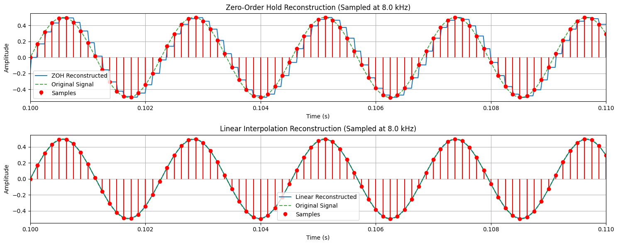
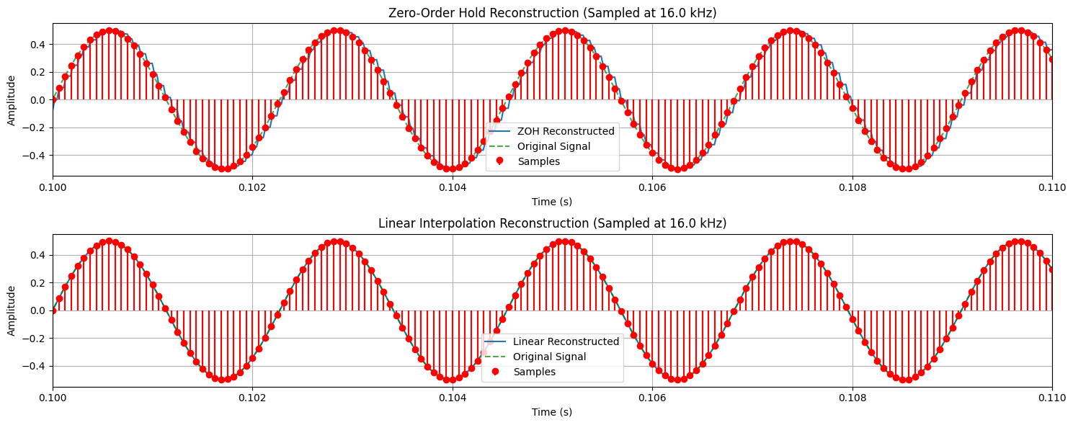
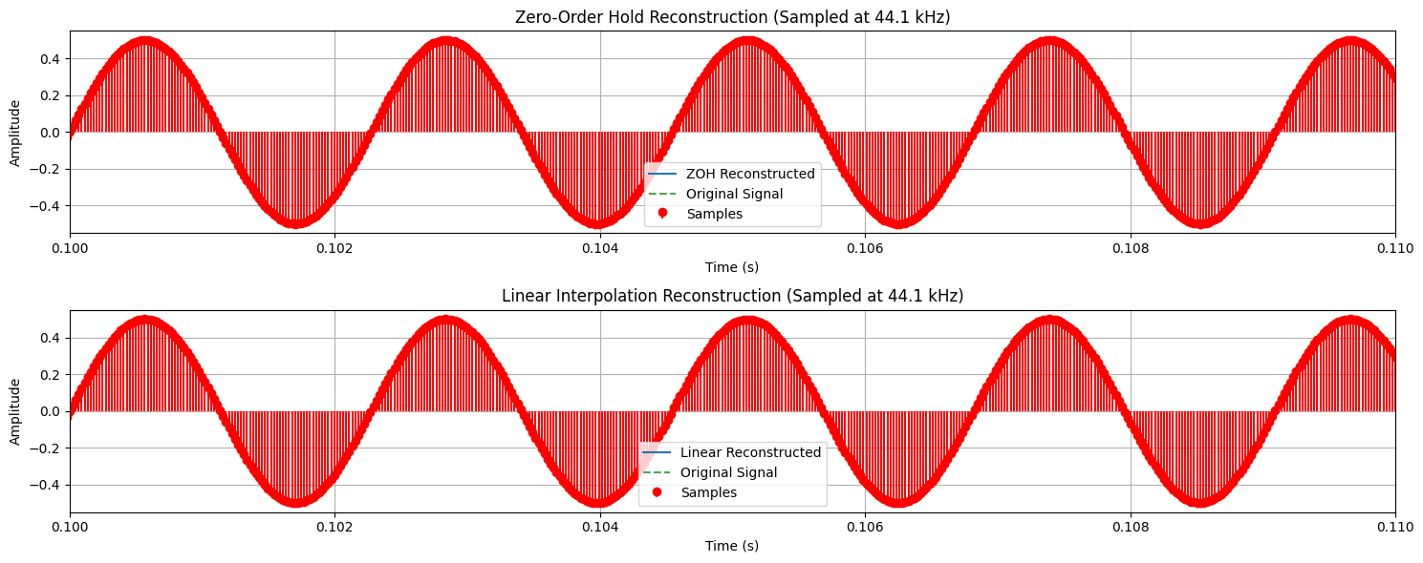

4. Calculate Mean Squared Error (MSE)
Visual inspection is good, but a quantitative measure is better for comparing the reconstruction quality. We will now calculate the Mean Squared Error (MSE) between the original signal and each of our reconstructed signals.
The formula for MSE is:
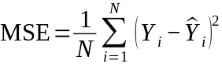
Where:
N is the total number of samples.
Yi is the value of the original signal at sample i.
Ŷi is the value of the reconstructed signal at sample i.
A smaller MSE value indicates that the reconstructed signal is a better approximation of the original signal.
# (1e) Calculate the Mean Squared Error (MSE)
def mean_squared_error(original, reconstructed):
"""Calculates the Mean Squared Error between two signals."""
return np.mean((original - reconstructed)**2)
print("--- Mean Squared Error (MSE) ---")
for rate in target_rates:
# Ensure the original signal is trimmed to the same length as the reconstructed one
# This is important if resampling caused a slight length mismatch
min_len = min(len(original_signal), len(reconstructed_signals_zoh[rate]))
trimmed_original = original_signal[:min_len]
# MSE for Zero-Order Hold
mse_zoh = mean_squared_error(trimmed_original, reconstructed_signals_zoh[rate][:min_len])
# MSE for Linear Interpolation
mse_linear = mean_squared_error(trimmed_original, reconstructed_signals_linear[rate][:min_len])
print(f"\nSampling Rate: {rate/1000} kHz")
print(f" MSE (Zero-Order Hold): {mse_zoh:.10f}")
print(f" MSE (Linear Interpolation): {mse_linear:.10f}")
--- Mean Squared Error (MSE) ---
Sampling Rate: 8.0 kHz
MSE (Zero-Order Hold): 0.0142084077
MSE (Linear Interpolation): 0.0033023673
Sampling Rate: 16.0 kHz
MSE (Zero-Order Hold): 0.0029288142
MSE (Linear Interpolation): 0.0005043589
Sampling Rate: 44.1 kHz
MSE (Zero-Order Hold): 0.0000000000
MSE (Linear Interpolation): 0.0000000000

Inference
Based on the plots and the Mean Squared Error (MSE) values calculated above, write your conclusion here.
Key points to consider:
- Effect of Sampling Rate: How did the MSE change as the sampling rate increased from 8 kHz to 44.1 kHz? What does this tell you about the relationship between sampling rate and reconstruction accuracy?
- Comparison of Reconstruction Methods: For any given sampling rate, which method (Zero-Order Hold or Linear Interpolation) consistently produced a lower MSE? What does this imply about the effectiveness of the two methods?
- Audible Quality (Optional): If you played the audio for each reconstructed signal, how did the sound quality change with the sampling rate and reconstruction method? Did the audible quality match what the MSE values suggest?
- Nyquist Theorem: The original signal was a 440 Hz sine wave. According to the Nyquist-Shannon sampling theorem, what is the minimum sampling rate required to perfectly reconstruct this signal? How does this relate to your results for the 8 kHz, 16 kHz, and 44.1 kHz rates?

(2) Implement the source-filter model for a given speech signal and analyze the impact of sampling and reconstruction on the quality of the speech signal.
(a) Generate a synthetic speech signal using the source-filter model.
(i) Create a source signal (e.g., a glottal pulse train for voiced sounds or white noise for unvoiced sounds).
(ii) Apply a filter that models the vocal tract, represented by an all-pole filter or an FIR filter with formants (resonances of the vocal tract).
(b) Plot the generated speech signal and analyze the effect of the filter on the original source.
(c) Sample the speech signal generated above at different sampling rates (e.g., 8 kHz, 16 kHz, 44.1 kHz).
(d) Reconstruct the signal using a suitable interpolation method (e.g., zero-order hold, linear interpolation).
(e) Compute the Mean Squared Error (MSE) between the original and reconstructed speech signals.
Write an inference on tasks such as creating the source-filter model, different sampling rates, and reconstruction of the sampled signals.

Code with Results

import numpy as np
import matplotlib.pyplot as plt
from scipy import signal
from scipy.io import wavfile
import sounddevice as sd
Source: A source signal is generated by the lungs and vocal folds (glottis). This is either a periodic pulse train for voiced sounds or random noise for unvoiced sounds.

Filter: The source signal then passes through the vocal tract (the throat, mouth, and nasal cavities), which acts as a time-varying filter. This filter shapes the spectrum of the source signal, creating the different sounds of speech by emphasizing certain frequencies (called formants).
In this task, we will create a synthetic speech signal by first generating a source and then applying a filter to it.

1. Create the Source Signal
First, we'll generate the two types of source signals as described in the model.
- Voiced Source (Pulse Train): We create a series of pulses at a specific fundamental frequency (F0). A typical male F0 is around 120 Hz, and a female F0 is around 210 Hz.
- Unvoiced Source (White Noise): We generate random values to simulate the turbulent airflow for sounds like 'sh' or 'f'.
# (a.i) Create a source signal
# --- Parameters ---
sample_rate = 44100 # Hz
duration = 15 # seconds
F0 = 120 # Fundamental frequency for voiced sound (in Hz)
# --- Generate Time Vector ---
t = np.linspace(0., duration, int(sample_rate * duration), endpoint=False)
# --- 1. Voiced Source (Glottal Pulse Train) ---
# Create a pulse train: a pulse at every 1/F0 seconds
pulse_train = np.zeros_like(t)
pulse_period_samples = int(sample_rate / F0)
for i in range(0, len(pulse_train), pulse_period_samples):
pulse_train[i] = 1
# --- 2. Unvoiced Source (White Noise) ---
white_noise = np.random.randn(len(t))
# Normalize to be between -1 and 1
white_noise /= np.max(np.abs(white_noise))
# --- Plot the Source Signals ---
plt.figure(figsize=(12, 6))
# Plot Pulse Train
plt.subplot(2, 1, 1)
plt.plot(t, pulse_train)
plt.title('Source Signal: Voiced (Glottal Pulse Train)')
plt.xlabel('Time (s)')
plt.ylabel('Amplitude')
plt.xlim(0, 0.05) # Zoom in to see a few pulses
plt.grid(True)
# Plot White Noise
plt.subplot(2, 1, 2)
plt.plot(t, white_noise)
plt.title('Source Signal: Unvoiced (White Noise)')
plt.xlabel('Time (s)')
plt.ylabel('Amplitude')
plt.xlim(0, 0.05) # Zoom in to see the noise structure
plt.grid(True)
plt.tight_layout()
plt.show()
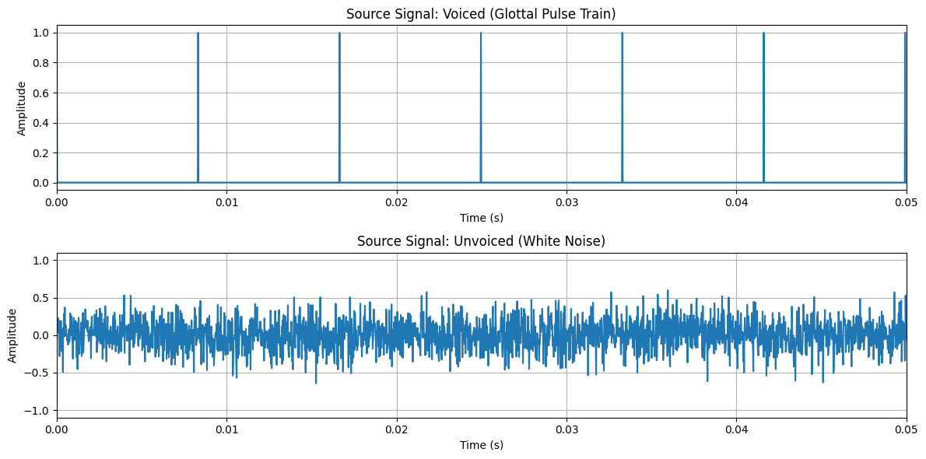

2. Create the Vocal Tract Filter and Generate Speech
Now we create the filter. We will model the vocal tract as an all-pole filter, which is a good approximation for non-nasal vowels. The filter is defined by the locations of its poles, which correspond to the formants of a speech sound.
We will define the first three formants (F1, F2, F3) and their bandwidths to simulate a vowel sound. For this example, we'll use formants that approximate the vowel /a/ (as in "cat").
Once the filter is created, we apply it to our source signals (pulse train and white noise) to generate synthetic speech.
# (a.ii) Apply a filter that models the vocal tract
def formants_to_filter(formants, bandwidths, fs):
"""Converts formant frequencies and bandwidths to all-pole filter coefficients."""
# This is a simplified way to create filter coefficients from formants.
# It creates second-order sections for each formant and combines them.
a_coeffs = np.array([1.0])
for F, BW in zip(formants, bandwidths):
# Convert formant frequency and bandwidth to pole radius and angle
r = np.exp(-np.pi * BW / fs)
theta = 2 * np.pi * F / fs
# Create second-order section for this formant
a_k = np.array([1, -2 * r * np.cos(theta), r**2])
# Convolve with the existing filter coefficients
a_coeffs = np.convolve(a_coeffs, a_k)
return a_coeffs
# --- Filter Parameters (for vowel /a/) ---
formant_freqs = [730, 1090, 2440] # Hz
formant_bws = [90, 110, 170] # Hz
# --- Create Filter Coefficients ---
# The 'b' coefficient is just [1] for an all-pole filter
b_coeffs = np.array([1.0])
a_coeffs = formants_to_filter(formant_freqs, formant_bws, sample_rate)
# --- Plot the Filter's Frequency Response ---
w, h = signal.freqz(b_coeffs, a_coeffs, worN=8000, fs=sample_rate)
plt.figure(figsize=(10, 5))
plt.plot(w, 20 * np.log10(abs(h)))
for f in formant_freqs:
plt.axvline(f, color='r', linestyle='--', alpha=0.7)
plt.title("Vocal Tract Filter Frequency Response (for vowel /a/)")
plt.xlabel("Frequency (Hz)")
plt.ylabel("Magnitude (dB)")
plt.grid(True)
plt.show()
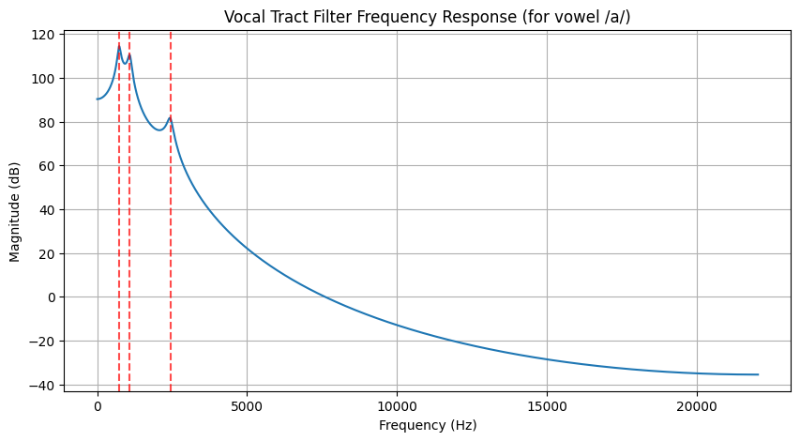

3. Plot the Generated Speech Signal
Now we apply the filter to the source signals and observe the result.
# (b) Plot the generated speech signal and analyze the effect of the filter
# --- Apply the filter to the source signals ---
# Voiced speech
voiced_speech = signal.lfilter(b_coeffs, a_coeffs, pulse_train)
voiced_speech /= np.max(np.abs(voiced_speech)) # Normalize
# Unvoiced speech
unvoiced_speech = signal.lfilter(b_coeffs, a_coeffs, white_noise)
unvoiced_speech /= np.max(np.abs(unvoiced_speech)) # Normalize
# --- Plot the generated speech signals ---
plt.figure(figsize=(12, 6))
# Plot Voiced Speech
plt.subplot(2, 1, 1)
plt.plot(t, voiced_speech)
plt.title('Generated Voiced Speech (/a/)')
plt.xlabel('Time (s)')
plt.ylabel('Amplitude')
plt.xlim(0.1, 0.15) # Zoom in
plt.grid(True)
# Plot Unvoiced Speech
plt.subplot(2, 1, 2)
plt.plot(t, unvoiced_speech)
plt.title('Generated Unvoiced Speech (filtered noise)')
plt.xlabel('Time (s)')
plt.ylabel('Amplitude')
plt.xlim(0.1, 0.15) # Zoom in
plt.grid(True)
plt.tight_layout()
plt.show()
# --- Listen to the generated sounds (optional) ---
# print("Playing synthetic voiced speech...")
# sd.play(voiced_speech, sample_rate)
# sd.wait()
# print("\nPlaying synthetic unvoiced speech...")
# sd.play(unvoiced_speech, sample_rate)
# sd.wait()
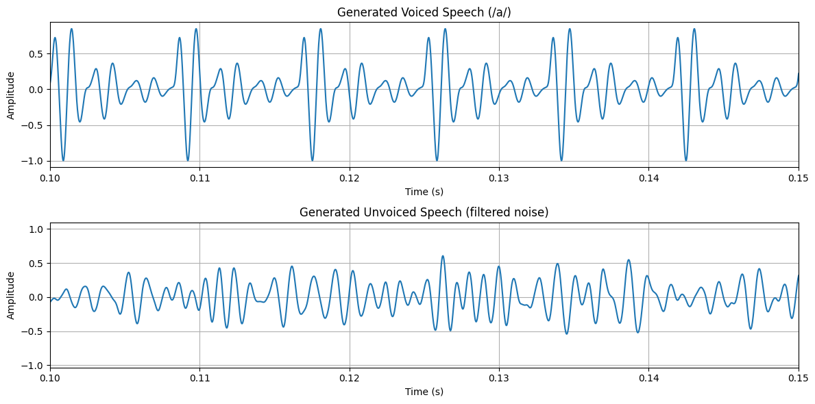

4. Sampling and Reconstruction of Synthetic Speech
Now, we will take the synthetic voiced_speech signal we just created and analyze how it is affected by sampling and reconstruction. This is the same process we followed in Task 1, but now applied to our model-generated signal.
# (c) Sample the speech signal generated above at different sampling rates
target_rates = [8000, 16000, 44100] # Hz
original_synthetic_signal = voiced_speech
original_rate = sample_rate # This is 44100 Hz
sampled_synthetic_signals = {}
print("--- Sampling Synthetic Signal ---")
for rate in target_rates:
# Calculate the number of samples in the resampled signal
num_samples = int(len(original_synthetic_signal) * rate / original_rate)
# Resample the signal
sampled_signal = signal.resample(original_synthetic_signal, num_samples)
sampled_synthetic_signals[rate] = sampled_signal
# Create a time axis for the sampled signal
sampled_time = np.linspace(0., duration, num_samples)
# Plot the sampled signal
plt.figure(figsize=(12, 4))
plt.stem(sampled_time, sampled_signal, basefmt=" ")
plt.title(f'Synthetic Speech Sampled at {rate / 1000} kHz')
plt.xlabel('Time (s)')
plt.ylabel('Amplitude')
plt.grid(True)
plt.xlim(0.1, 0.12) # Zoom in to a 20ms segment
plt.show()
--- Sampling Synthetic Signal ---
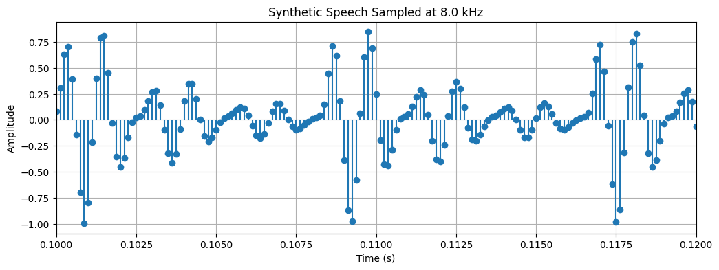
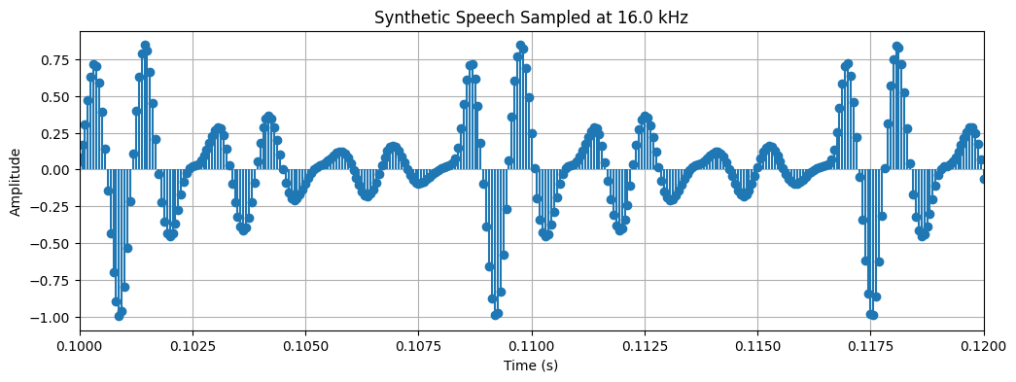
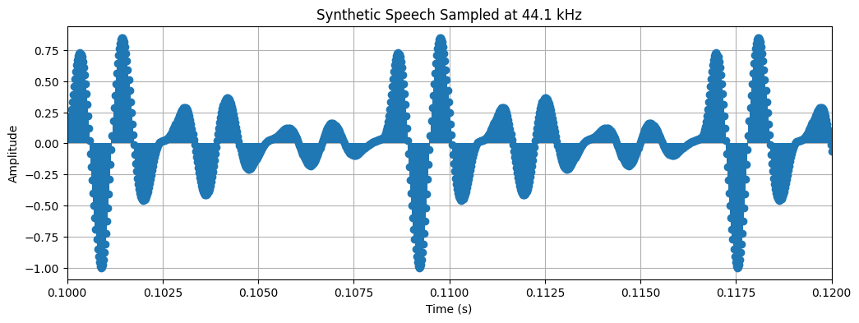

5. Reconstruct and Calculate MSE
We'll now reconstruct the signal from the samples using both Zero-Order Hold and Linear Interpolation, and then calculate the Mean Squared Error to quantify the reconstruction quality.
# (d) Reconstruct the signal using a suitable interpolation method
# (e) Compute the Mean Squared Error (MSE)
from scipy.interpolate import interp1d
def mean_squared_error(original, reconstructed):
"""Calculates the Mean Squared Error between two signals."""
return np.mean((original - reconstructed)**2)
print("--- Reconstruction and MSE Analysis ---")
for rate, sampled_signal in sampled_synthetic_signals.items():
# --- Time axes ---
sampled_time = np.linspace(0., duration, len(sampled_signal))
original_time = np.linspace(0., duration, len(original_synthetic_signal))
# --- Reconstruction ---
# Zero-Order Hold
f_zoh = interp1d(sampled_time, sampled_signal, kind='zero', fill_value="extrapolate")
reconstructed_zoh = f_zoh(original_time)
# Linear Interpolation
f_linear = interp1d(sampled_time, sampled_signal, kind='linear', fill_value="extrapolate")
reconstructed_linear = f_linear(original_time)
# --- MSE Calculation ---
mse_zoh = mean_squared_error(original_synthetic_signal, reconstructed_zoh)
mse_linear = mean_squared_error(original_synthetic_signal, reconstructed_linear)
print(f"\nSampling Rate: {rate/1000} kHz")
print(f" MSE (Zero-Order Hold): {mse_zoh:.10f}")
print(f" MSE (Linear Interpolation): {mse_linear:.10f}")
# --- Plotting ---
plt.figure(figsize=(15, 6))
plt.plot(original_time, original_synthetic_signal, 'g--', label='Original Synthetic Signal', alpha=0.5)
plt.plot(original_time, reconstructed_linear, 'b-', label='Linear Reconstructed')
plt.plot(original_time, reconstructed_zoh, 'm-', label='ZOH Reconstructed', alpha=0.7)
plt.stem(sampled_time, sampled_signal, 'r', markerfmt='ro', basefmt=' ', label='Samples')
plt.title(f'Reconstruction from {rate/1000} kHz Sampling')
plt.xlabel('Time (s)')
plt.ylabel('Amplitude')
plt.legend()
plt.xlim(0.1, 0.11) # Zoom in
plt.grid(True)
plt.show()
--- Reconstruction and MSE Analysis ---
Sampling Rate: 8.0 kHz
MSE (Zero-Order Hold): 0.0412632130
MSE (Linear Interpolation): 0.0097708626
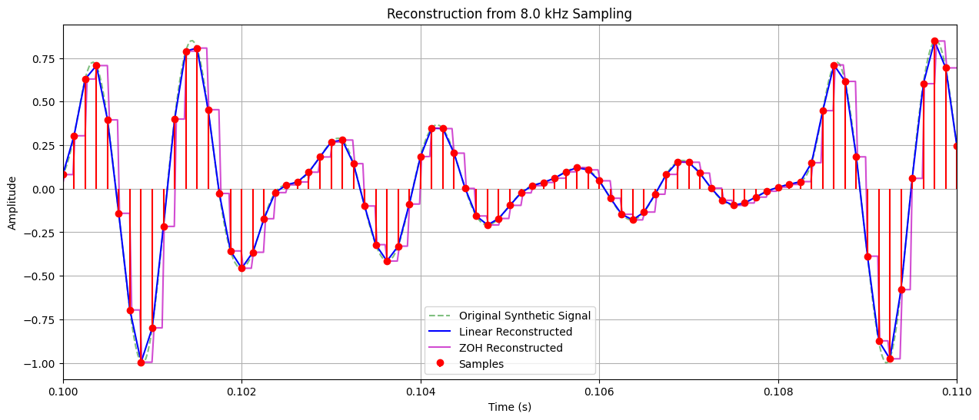
Sampling Rate: 16.0 kHz
MSE (Zero-Order Hold): 0.0088629615
MSE (Linear Interpolation): 0.0015359993
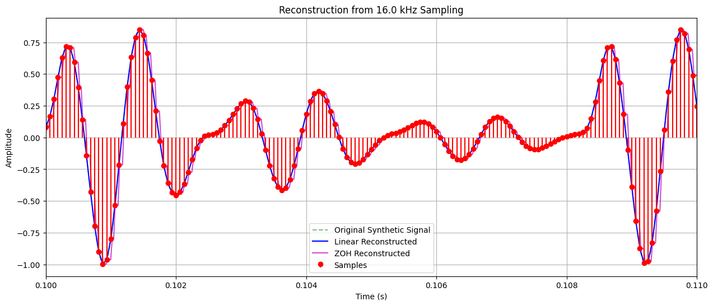
Sampling Rate: 44.1 kHz
MSE (Zero-Order Hold): 0.0000000000
MSE (Linear Interpolation): 0.0000000000
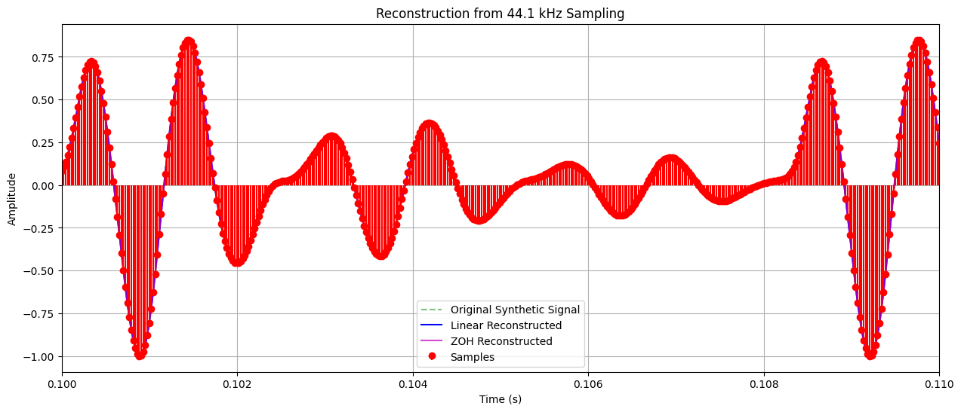

Inference
Based on the source-filter model implementation, the subsequent sampling, and the reconstruction results, write your final inference here.
Key points to consider:
- Source-Filter Model: How did the filter change the source signal (pulse train)? Did the frequency response of the filter match the resulting waveform of the synthetic speech?
- Effect of Sampling Rate on Synthetic Speech: How did the MSE for the synthetic speech change as the sampling rate was lowered? Was the effect similar to what you observed in Task 1 with the real audio file?
- Reconstruction Methods: Which reconstruction method performed better for the synthetic signal, according to the MSE values?
- Overall Conclusion: Summarize the entire process, from creating a synthetic vowel sound to analyzing the digital representation errors introduced by sampling.

